Wealth, Education, and Childhood Anemia in Nigeria
Independent Data Analysis — 2018 Nigeria Demographic and Health Survey (NDHS)
Saitu Yohanna

1. Research Question & Why It Matters
Does a mother's education level protect her child against anemia even after accounting for household wealth — or is the well-known link between maternal education and child health simply a reflection of wealthier mothers being more educated?
This matters because wealth and education move together in most households, so it is tempting to treat them as one lever. If education's protective effect is really just wealth in disguise, the most efficient anti-anemia intervention is income-focused (cash transfers, subsidised food, economic empowerment). But if education has an effect of its own, then health-literacy and girls'/women's-education programmes deserve investment independently of — and possibly ahead of — pure income interventions, since they may be cheaper to scale and reach households that will not be lifted out of poverty quickly.

2. Methods

Columns used and duplicate handling
The dataset contains two hemoglobin/anemia column pairs. One is adjusted for altitude and smoking — smoking is only asked of adults, so this pair belongs to the mother. The other is adjusted for altitude only, which matches how the DHS measures children (who are not asked about smoking); this pair ("Hemoglobin level adjusted for altitude" and "Anemia level.1") is the child's result and is the outcome variable for this analysis. The mother's own anemia/hemoglobin pair was excluded, since the research question is about the child. The two explanatory variables used are Wealth index combined (5 ordered categories) and Highest educational level (4 ordered categories, referring to the mother).

Cleaning
Child hemoglobin is only recorded for 10,182 of the 33,924 rows — the DHS draws blood only from a designated subsample of children, not from every child in the survey. The analysis is restricted to these 10,182 tested children, since untested children have no outcome to analyse; this is a standard, designed subsample rather than random data loss, so results describe the tested group. Wealth and education categories were put in their natural order (Poorest→Richest, No education→Higher) so charts read left-to-right by severity. A binary "Anemic" flag (Mild, Moderate, or Severe = anemic) was created alongside the four-level detail to simplify the headline comparison. Hemoglobin values were checked for DHS sentinel missing-codes (e.g. 999); none were present in this extract.

Tool
Python (pandas for reshaping and grouping, matplotlib for charts, SciPy for a chi-square significance check). A script-based tool suited this task because the outcome variable's missingness pattern needed to be handled deliberately before any aggregation, and because the same cross-tabulation logic had to be run at three levels of granularity (wealth alone, education alone, wealth × education together).

Technique
Grouped proportions / cross-tabulation: the % of children anemic was calculated within each wealth category, each education category, and then within each wealth × education combination together. A chi-square test of independence checked whether the wealth and education patterns are statistically significant rather than sampling noise. Regression was considered but not used — the question is about a moderation pattern across a handful of categorical groups, which a cross-tab communicates directly to a non-technical reader without requiring interpretation of model coefficients.

3. Findings
Among the 10,182 Nigerian children with a measured hemoglobin result, 68.8% were anemic (mild, moderate, or severe) — a very high baseline that puts both wealth and education gaps in context.
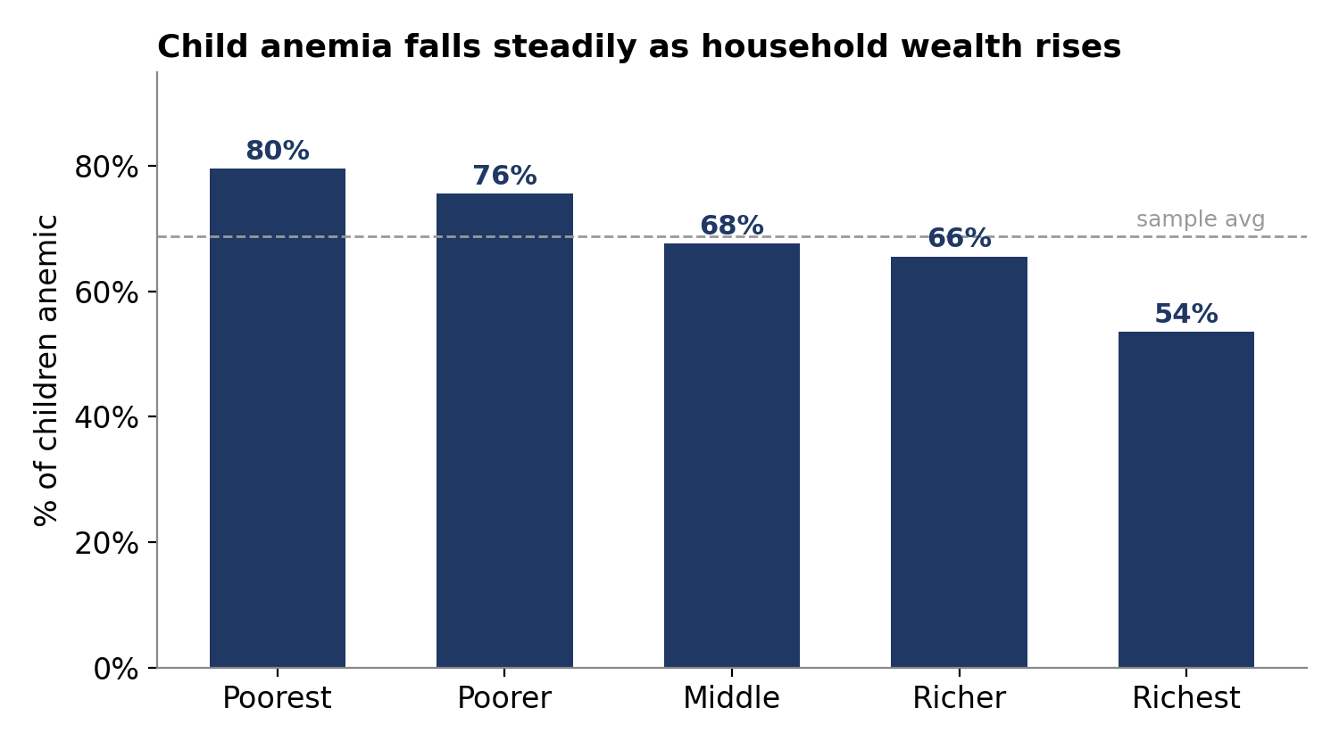
Figure 1 — Child anemia rate by household wealth quintile.
Anemia falls steadily as wealth rises, from 80% in the poorest households to 54% in the richest — a 26-point gap.
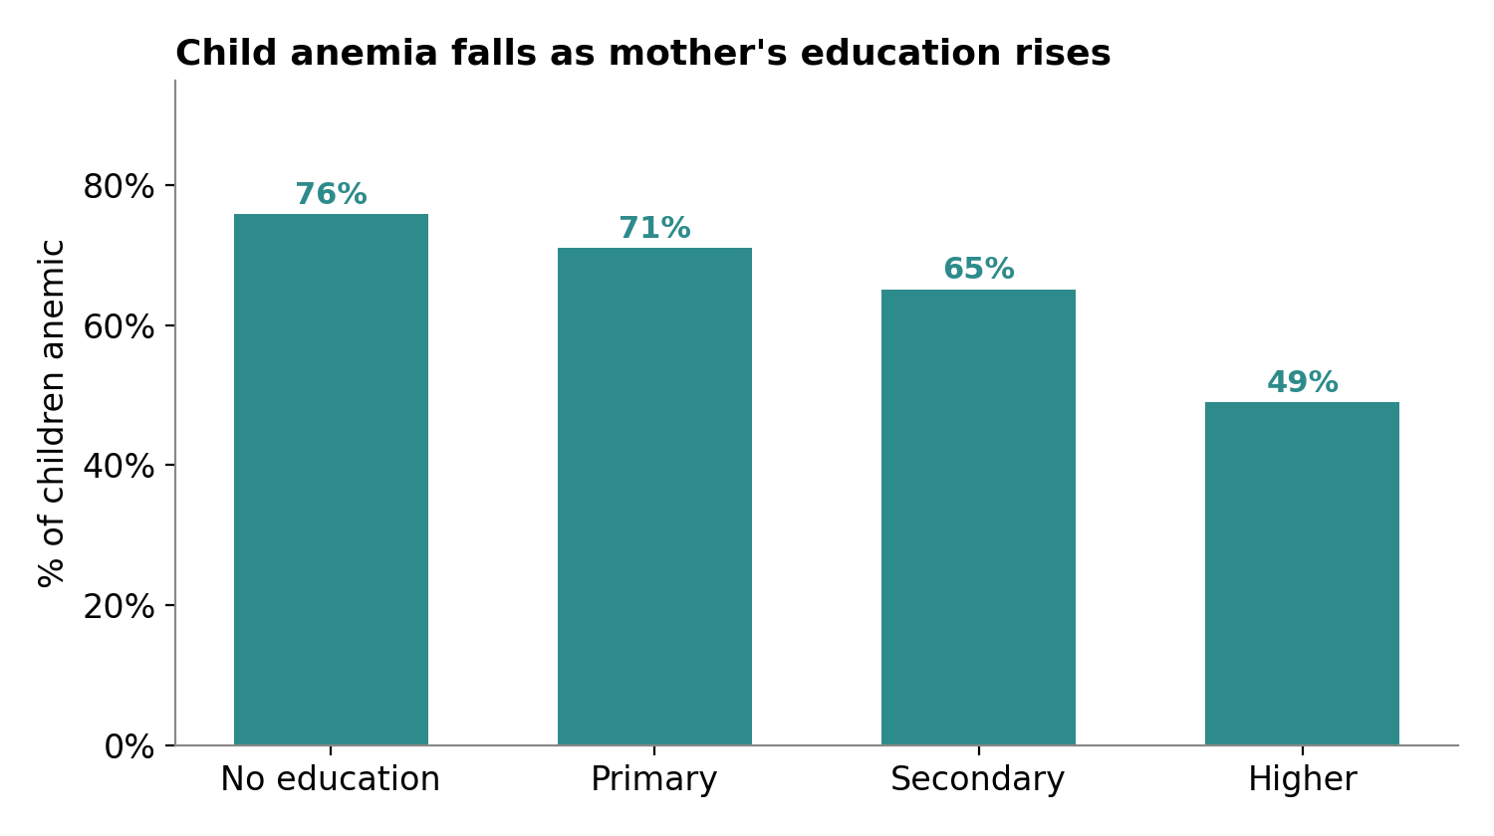
Figure 2 — Child anemia rate by mother's highest education level.
The same downward pattern appears for education: 76% among children of mothers with no education, falling to 49% for mothers with higher education — a 27-point gap, similar in size to the wealth gap.
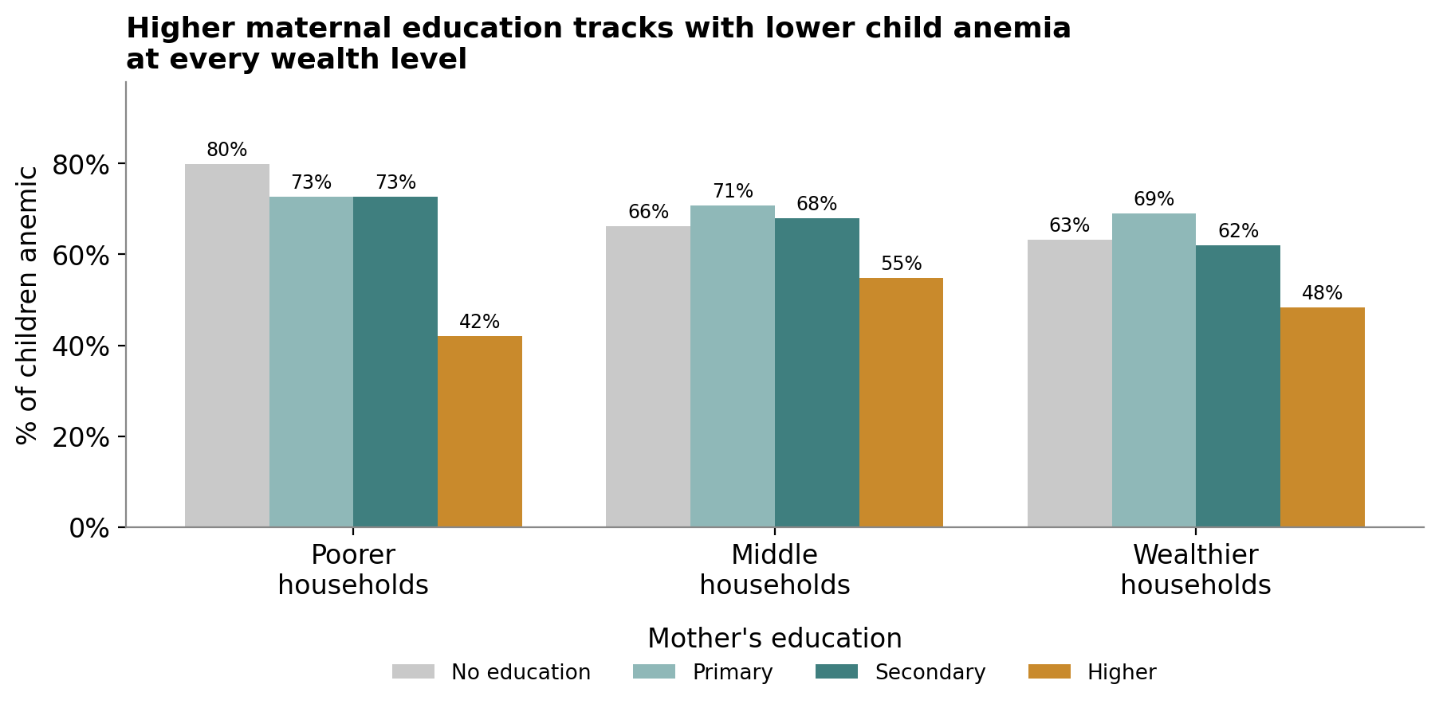
Figure 3 — Child anemia rate by wealth band and mother's education, shown together.
This is the key result. Within every wealth band, children of mothers with "Higher" education have a markedly lower anemia rate than children of mothers with No education, Primary, or Secondary schooling in the same wealth band — 42% vs. 63–80% in poorer households, and still 48% vs. 62–69% in wealthier households. The gap between "No education/Primary/Secondary" is comparatively small and inconsistent, but "Higher" education stands out clearly as protective at every income level. Both the wealth pattern and the education pattern are statistically significant (chi-square p < 0.001 for each), so they are very unlikely to be due to chance.
Caveat: two cells are based on small samples — "Higher education" mothers in poorer households (n = 19) and "No education" mothers in the richest households (n = 73) — so those exact percentages should be read as indicative, not precise. The direction of the pattern, however, is consistent across every wealth band.

4. Conclusion
Household wealth and maternal education are both strongly linked to child anemia, but they are not just two names for the same thing. Even within the same wealth band, a mother's education — specifically reaching the "Higher" level — is associated with a large drop in her child's anemia risk. This suggests that closing Nigeria's child-anemia gap will take more than raising household income: expanding girls' and women's access to higher education, or delivering the health knowledge that tends to come with it, looks like an independent and complementary lever. A programme that only targets income may leave a substantial part of the gap untouched.

